Notes on Azure Storage Accounts

**Azure Storage Accounts**

There are different types of storage accounts

* **General-purpose v2 accounts**– This is recommended for most scenarios. This storage account type provides the blob, file , queue and table service.
* **General-purpose v1 accounts**– This also provides the blob, file , queue and table service, but is the older version of this account type.
* **BlockBlobStorage accounts**– This is specifically when you want premium performance for storing block or append blobs.
* **FileStorage accounts**– This is specifically when you want premium performance for file-only storage.
* **BlobStorage accounts**– This is a legacy storage account. Use General-purpose v2 account as much as possible

**More on Azure Blob storage**

* This is object storage for the cloud.
* Here you can store massive amounts of unstructured data on the cloud.
* This is highly recommended when you want to store images, documents, video and audio files.
* Within the blob service, you create a container that is used to store the blob objects.
* There are three different types of blobs

**Block blobs** – This is used for storing text and binary data.

**Append blobs** – This is ideal for logging data.

**Page blobs** – This is used to store virtual hard disk files for Azure virtual machines

**Replication Techniques**

* *Locally-redundant storage (LRS)*- Here data is replicated synchronously three times within a physical location in the primary region.
* *Zone-redundant storage (ZRS)*- Here data is replicated synchronously across three Azure availability zones in the primary region. This is good when you want to have data present even in the event of a data center failure.
* *Geo-redundant storage (GRS)*- Here data is replicated synchronously three times in the primary region, then replicated asynchronously to the secondary region.
* *Read access Geo-redundant storage (RA-GRS)*- Here data is replicated synchronously three times in the primary region, then replicated asynchronously to the secondary region. Here the data in the secondary region is also available for read-only purposes.
* *Geo-zone-redundant storage (GZRS) -*Here data is replicated synchronously across three Azure availability zones in the primary region, then replicated asynchronously to the secondary region.
* *Read Access Geo-zone-redundant storage (RA-GZRS) -*Here data is replicated synchronously across three Azure availability zones in the primary region, then replicated asynchronously to the secondary region. Here the data in the secondary region is also available for read-only purposes.

Here is a snapshot from the Microsoft documentation on the different storage account types

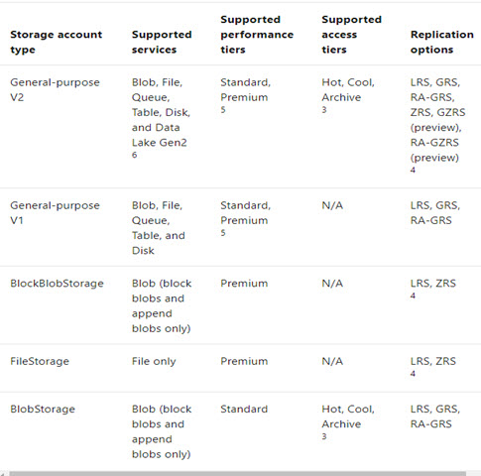

Reference - <https://docs.microsoft.com/en-us/azure/storage/common/storage-account-overview>

**Azure Blob Storage - Access Tiers**

***Hot***– This is optimized for storing data that is accessed frequently. This can be set at the account level.

***Cool***– This is optimized for storing data that is infrequently accessed and stored for at least 30 days. This can be set at the account level.

**Note:- For the Cool Access tier , the storage costs are lower than the Hot tier. But the access costs are higher than the Hot access tier.**

***Archive tier***- This is optimized for storing data that is rarely accessed and stored for at least 180 days. This can be set only at the blob level.

**Note:- When a blob is in the archive tier, you can’t access the blob. You have to rehydrate the blob first before it can be accessed.**

**Also the storage costs are the least when it comes to the Archive access tier. But the access costs are the highest**